CAN YOU STOMACH THE BEST OF RUSHDIE?
"The Satanic Verses"
unexpurgated
By Ahmed Deedat
THE PEN AND THE SWORD
So far 'Satanic' Salman has succeeded in causing the death of 40 Muslim men, widowed Muslim women and orphaned Muslim children with his poisoned pen, proving the old saying (if proof was needed) that "The Pen is Mightier than the Sword!"
Despite all my anger, sorrow and bitterness i still plead with my fellow Muslims in travail - "Stop crying", "Don't wail!", "No more protest marches or book burning!" All our visible signs of pain and anguish are giving the enemies of Islam gleeful sadistic pleasures. I say, STOP IT! Turn the Tables!
TURNING THE TABLES
Let us learn a lesson from the life of Jesus Christ (peace be upon him). His detractors came to him again and again with posers - and riddles as recorded in the Christian New Testament. His own people, the Jews, came to him, whit mockery on their lips and mischief in their hearts, saying "Master, we caught this women in the act of adultery, what must we do to her?" [Pick up your Free copy of the book - "ARABS and ISRAEL - Conflict or Conciliation?" from the Centre for a detailed exposition of these episodes] Jesus turned the tables on the Jews. Again, on another occasion, they said, "Master, must we pay tribute (taxes) to Caesar or not? Once more again Jesus turned the tables on the Jews in the temple of Solomon on his triumphant march into Jerusalem with his disciples, he physically overturned the money-changers´ tables and, with a corded whip, whipped them out of the Temple [ For full details get your Free copy of "CRUCIFIXION or CRUCIFICTION?" When ordering by mail, please consider enclosing postage money. Don't kill the goose that lays golden egg.] We shamefully acknowledge that we lack the potency to whip anybody, but every Muslim who reads these words and understands what he is reading can turn the tables on every Westerner who defends Rushdie.
UNEXPURGATED RUSHDIE
There is no way of cleaning the stable without dirtying your hands. I have seen numerous TV programmes debating Rushdie´s "Satanic Verses." But not one, I repeat again NOT ONE, Muslim defender of our Cause grappled with the nettle. One who came nearest was one of our intellectuals who, when prodded as to what in Rushdie´s book created such terrible umbrage in the Muslim minds, in Rushdie´s work, timidly quoted the word "bhaenchud" Satanic Salman´s "The Satanic Verses."
What did this word "bhaenchud mean to some 50 million American viewers on ABC or was it PBS TV network? Absolutely NOTHING!
"Bhaenchud" is only for starters. You have been warned. This publication , the word "UNEXPURGATED" , which means that Rushdie´s text in his original "The Satanic Verses" are not tampered with. That nothing is done by me to remove, expunge, erase any obscene or pornographic word or phrase. If you can´t stomach Rushdie´s "shit"[ This is a very mild expression from Rushdie's book. See and hear me on video "Is Jesus God?", a debate with Dr Shorrosh in which I was hard put skirting round and round this word and yet never coming to uttering it: in deference to my audience.] in print, please tear up this publication and throw it in your toilet pan. In all my lectures on Rushdie, I had warned my audiences in advance that my talks were "Definitely not for Prudes, children and Bashful Men and Women"!
From now on, you can look forward to sharing the "gems" (the shit which Rushdie has excreted) whit your Western friends and neighbours. Create opportunities to expound "The Satanic Verses".
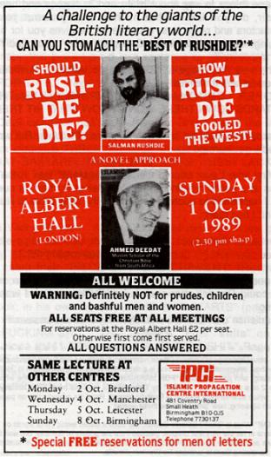
A NOVEL APPROACH
Begin like this - "Admitted that Rushdie has many filthy, dirty and obscene things to say about Islam and its heroes and heroines: but sir, do you know what he has to say about you, his benefactors and protectors, what thanks he gives you for his upbringing, cultural and moral deportment, and unsolicited refuge and hospitality?"
On the very first[The actual first page of chapter One is numbered 3. Because this Satan has counted Nos 1 and 2 without enumerating them, ie. No 1 is a dedication to his living companion in "Hell" (of his own making) with just two words "FOR MARRIANE" his second spouse, on the whole page and No 2 is a prologue on "SATAN" by Daniel Defoe from his Book "The History of the Devil" which astonishingly enough is Rushdie himself. Read the reproduction on page 6; you can't help agreeing, how "prophetic" are those words!]page of "The Satanic Verses", Rushdie calls his god-fathers the British- "PROPER LONDON, BHAI![ . "BHAI!" What is "bhai" Satanic Salman has used a dozen exotic Hindi words on the first page alone in his the very first chapter, gleaned from the gutters of Bombay. But wait for what he spews out from the sewers of his birthplace. He scatters his obscenities a hundred times without translating them to tantalise his Western dimwits.] HERE WE COME! THOSE BASTARDS DOWN THERE WON'T KNOW WHAT HIT THEM."
Bastards! He could have said those sons of bitches. But wait, let Rushdie get warmed up.
The first time i ever uttered the word "bastard" was in the early sixties at a public meeting in the City Hall of Durban, at question time, I happened to quote a verse from the Holy Bible to illustrate a point; I had read:
"The bastard shall not enter the conregation of the Lord; even unto the tenth generation...?" Deuteronomy 23:2
This one word - bastard, nearly brought the roof down on me! How could Deedat utter such a word? Remember, I was only quoting! My audience did not know that this Anglo-Saxon unsavoury word bastard was repeated in the "Book of Books" only three times, in nearly 1,500 pages. Rushdie does it 29 times in his bid to beat all records for all times in his tome of 500, double-spaced, sparasely typed pages. Observe this evil genius constructing a one-word sentence out of it.
"THAT, AND ALSO HER, THE ICEWOMAN, BASTARD. (note: this b-a-s-t-a-r-d is a sentence by itself) NOW THAT I AM DEAD I HAVE FORGOTTEN HOW TO FORGIVE. " Page 8 of the Devil's "The Satanic Verses" (in short TVS in all future references.).
This Devil incarnate has learnt from his British peers the art of staccato sentences. Now watch him do the impossible whit words. He can introduce THREE "bastards" in a single short sentence..."THAT BASTARDS, THOSE BASTARDS, THEIR LACK OF BASTARDS [Rushdie's own emphasis] TASTE" (PAGE 137 TSV).
WHAT A PRIZE!
Could Viking/Penguin, the publishers of this filth, have given Rushdie eight hundred thousand dollars ($800,000) as advance money for this? Not likely! They have good (?) business sense. They smelt their "PIECE OF PIG EXCREMENT" (Rushdie's words: page 7 TVS), "ROTTEN COCKROACH DUNG" (page 13 TVS). Not smelly enough? Rushdie excretes his shit quite late in his book; in his own words - "THE SHIT STARTS" (page 434 TVS). Please check up! "THIS SHIT, YOU CUNTS," "IT'S SHIT," "IT'S FUCKING SHIT," "SHIT DINNER," Four "shits" on one page alone (p441 TVS), page 449 "THREW SHIT." Page 461 "WHIT MAN'S SHIT," there must be something special in it for this Brown Britisher, because he says, "BLACK SHIT IS BAD," on page 529 of his bullshit book TVS, and also on page 461 "NIGGER EAT WHITE MAN'S WHIT," and he shuns his reasons, as to why!
PROLOGUE
Satan, being thus confined to a vagabond, wandering, unsettled condition, is without any certain abode; for though he has, in consequence of his angelic nature, a kind of empire in the liquid waste or air, yet this is certainly part of his punishment, that he is ... without any fixed place, or space, allowed him to rest the sole of his foot upon.
Daniel Defoe, The History of the Devil
All this shit of Rushdie will not satiate Peter Mayer the Director of Penguin and his fellow gluttons. They need something more sicky and stinky to satisfy their depraved tastes. And, Rushdie is their man of the hour. There will never be another to get away whit the lampooning of Hindus, Muslims, Christians and Jews. Blacks as well as all Whites! Not even sparing the "Iron Lady" nor the Queen of Great Britian. If you, the reader, have come thus far, you might as well go the whole hog. Finish this book!
SELECTIVE SENSITIVITY
Everyone in the West, British and American, giants of the literary world, are not impervious to sacrilege, insults and profanities as contained in "The Satanic Verses". Roald Dahl, a British author and member of the Literaray Guild had some pertinent remarks as reproduced from "The Daily News" dated March 1 st, 1989 (see next page). Cynical supporters of Rushdie's rights of freedom of speech and expression might say that for Dahl it was a question of "sour grapes", not having been nominated for the short-list of the prestigious "Book Award" himself.
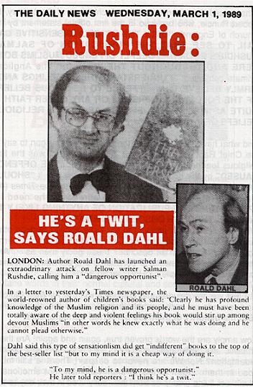
CHRISTIAN AND JEW UNITE
What would they say of the Archbishop of Canterbury, Dr Robert Rucie, who has said in the first official statement by the Church of England "ONLY THE UTTERLY INSENSITIVE CAN FAIL TO SEE THAT THE PUBLICATION OF SALMAN RUSHDIE'S BOOK HAS DEEPLY OFFENDED MUSLIMS BOTH HERE AND THROUGHOUT THE WORLD." The Anglican Primate continued: "I UNDERSTAND THEIR FEELINGS AND I FIRMLY BELIEVE THAT OFFENCE TO RELIGIOUS BELIEFS OF THE FOLLOWERS OF ISLAM OR ANY OTHER FAITH IS QUITE AS WRONG AN OFFENCE AS TO THE RELIGIOUS BELIEFS OF CHRISTIANS."
And what have the dullards on the Rushdie bandwagon to say of the Chief Rabbi of Britain, Lord Jakobovits, who has the first religious leader in Britain to "DEPRECATE....THE OFFENCE CAUSED" by the book, has reiterated his view that it "SHOULD NOT HAVE BEEN PUBLISHED." In a letter to The Times (4th March 1989) the Chief Rabbi also agreed on the need for "PROHIBITING THE PUBLICATION OF ANYTHING LIKELY TO INFLAME, THROUGH OBSCENE DEFAMATION..." What motives can we attribute to the three above? Nothing other than the Love of God and Love of Man based on Eternal Thrust. The Holy Qur'an describes these godly men as "And among them (the Jews and Christians) are Mu'mins, (meaning Faithful, Sincere People)..." Holy Qur'an 3:110
But lest we are deluded into complacency, the All-Wise Merciful God reminds us in the concluding phrase of the above verse "But the majority of them are perverted transgressors."
How amply are the words proven true, again and again! Are these atheistic and materialistic so-called Jews and Christians beyond redemption? No! We are never to despair! There is still much good in them. Learn to talk to them rationally, not emotionally. Give them living examples from their day-to-day affairs.
MPs ANGERED
Datelined from London, on the 22nd May, 1989, was a roaring headline in "The Daily News."

I sympathise with the British in their righteous indignation. Though the English-speaking people, both British and American, bandy around not only four-letter words, but five- and seven-letter profane words in their normal cultural and social relationships. Yet they are highly sensitive when the same words are used in connection with their own heroes and heroines.
DOUBLE STANDARDS
What grates me most is the rank hypocisy of the one thousand and one Poets, Playwrights and Pimps; Editors, Essayists and Eunuchs; Novelists, Newspaperman and Non-Conformists who signed and paid for adverts in the National Newspapers in support of Rushdie's right to absolute freedom of speech and expression.
Yet not a single one of those thousand will raise an eyebrown in defending Rourke's right to use just a four-letter word even once. Not against Mrs. Thatcher in person but against her economic Policies. Their hypocrisy is unbearable!
What was that "four-letter" word wich roused such fury and ire among a people reputed for their calm, placid, sagacity? It is downright silly to beat around the bush. That emotive word is F-U-C-K! Because of this single four-letter word, Lady Chatterley-s Lover was banned in South Africa for twenty years! Even the dullest of the English-speaking people conjure up the word "fuck", when the expression "four-letter" is used.
A TETRAGRAMATTON
The Jehovah's Witnesses, a very active and most militant evangelistic Christian sect, never use the expression "four-letter word" in any of their literature though a four-letter word is the kingpin of their preaching.[ Obtain your FREE copy of the book "What is his name?" from the Centre for fuller explanation.] They have invented a fourteen-letter word to describe a four-letter word. Imagine! They ever and anon substitute "TETRAGRAMATTON" instead of simply the word "four".
Rushdie has overcome this typical British aversion by making a "four-letter" word into a seven-letter word by simply adding the present participle suffix to the word FUCK by adding I-N-G, making it FUCKING. See how adoritly he made the whole British nation swallow the word FUCKING while Rourke's "FUCK" was gettting stuck in their throats.
"OH. SHE'S (Maggie) RADICAL ALL RIGHT. WHAT SHE (Maggie) WANTS - WHAT SHE (Maggie) ACTUALLY THINKS SHE (Maggie) CAN FUCKING ACHIEVE IS LITERALLY...FROM FUCKING SURREY AND HAMPSHIRE...NOBODY'S EVER TRIED TO REPLACE A WHOLE FUCKING CLASS BEFORE...THIS COUNTRY THAT'S STUFFED FULL OF FUCKING OLD CORPSES. (Rushdie's "The Satanic Verses" page 270).
It is strange that the British can stomach four "fuckings" in one paragraph from Rushdie but one "fuck" from Rourke infuriates them. Is it because Rushdie is there brother-in-law and son-in-law combined? (Remember! His divorce first whife was British.) A cursory count will give you 5 FUCKS and 52 FUCKINGS in this what the Western world has called a literary masterpiece! Don't forget, only 52, just one "FUCKING" for every week of the year!
One can't help agreeing that "The Satanic Verses" is a masterpiece for fucking-up the English language. He has conjoined his word "FUCKING" with every letter of the alphabet. Here is a quick summary of some of them. Verify the rest at leisure.
With the Letter a: Pages from TVS

"FUCKING A" 245
"FUCKING ALLIES" 269
"FUCKING AMERICANS" 280
"FUCKING ARGENTINA" 268
"FUCKING BEATLES" 163
"FUCKING BEDPAN" 169
"FUCKING CLASS" 270
"FUCKING CREEP" 178
"FUCKING CLOWNS" 101
"FUCKING COMMANDOS" 80
"FUCKING DIFF?" 262
"FUCKING DYNASTY" 265
"FUCKING DOGS" 410
"FUCKING DREAMS" 122
"ENJOY FUCKING" 149
"FUCKING GUITAR" 269
"FUCKING HORNY" 158
"FUCKING HELLHOLE" 180
"FUCKING IDIOT" 526
Please forgive me, if it is getting too boring. Here is a little variation:
FUCKING TANK FUCKING PEE AITCH DEE FUCKING COUNTRY All this from a single page: 268 TVS FUCKING LIFE FUCKING NATION THE BASTARDS

Why you enjoy fucking with this one p 149
You are fucking my woman p 207
Don't holy men ever fuck? p 278
God's own permission to fuck p 386
I have had enough of this "fucking shit" (words borrowed from Satanic Salman). Let me end with a last bit "WILD DONKEYS FUCKING WEARILY AND DROPPING DEAD STILL CONJOINED" (page 479 TVS).
Dear reader, if any pervert, dolt or dullard protests that the foregoing quotations are out of context, then obtain the text (Satanic Salman's Satanic Verses). If you already have it then please buy three highlighters - red, yellow and green, and go to town in colour-coding Rushdie's shit. RED for all the "fuck" and "fucking" words. YELLOW for all the Hindi exotic words, like "bhaenchud", "yaar", "haramazada", etc. And GREEN for quotable verses: I'll refer you to them later.
Thus armed with a colour-coded "The Satanic Verses", you can plaster the cynics and mockers of Muslims With Rushdie's excrement. They ought to relish it, never mind how much they protest. It's food for the maggots! Like randy hooker Pamella Borders; Mother India also gave birth to Salman Rushdie, alias Satanic Salman, also "Saladin Chamcha" or "Spoono" and "Gibreel Farishta" all are one and the same - Rushdie of "Satanic Verses" fame. Nurtured in the Western culture, both Pamella and Salman spurned their faiths. At the tender age of thirteen, Rushdie was thrown into the laps of the West. He studied at Rugby and Cambridge in England and imbibed its culture. He went the whole hog. Listen to his philosophy, page 211 TVS ie "The Satanic Verses". He wrote -
"BUT TO BE RAISED IN THE HOUSE OF POWER IS TO LEARN ITS WAYS, TO SOAK THEM UP, THROUGH THAT VERY SKIN THAT IS THE CAUSE OF YOUR OPPRESSION. THE HABIT OF POWER, ITS TIMBRE, ITS POSTURE, ITS WAY OF BEING WITH OTHER. ITS IS A DISEASE, BILAL, INFECTING ALL WHO COME TOO NEAR IT. IF THE POWERFUL TRAMPLE OVER YOU, YOU ARE INFECTED BY THE SOLES OF THEIR FEET." TVS p 211
It is worth highlighting the above quotation in GREEN. Rushdie is giving here the source of his own inspiration and nourishment. He has imbibed the worst of both worlds! Now see, how he repays his British god-fathers for all their kind and generous hospitality.
He charges his British benefactors as an incestuous people. He calls them "THE SISTER FUCKING BRITISH." [All emphases in this quote, are Rushdie's own!] TVS p 80. This is the unkindliest cut of them all. He marries Pamela Lovelace according to his story in the TVS. And according to his own philosophy she was destined "FOR FUCKING AND THROWING OVER," which he did by divorcing her.
Where did he get the information from that the British fuck their own sisters? Perhaps his Pamela may have confided in him, and maybe he betrayed her trust.
THE IRON LADY
My wife has a special liking for Mrs. Thatcher. She cannot explain. She does not understand her politics. Perhaps it is the clarity of her voice and forceful speeches that attract her to the "Iron lady."
Islam forbids the giving of offensive nick-names to anybody. I take it that "Iron Lady" is not offensive. If it is, my apologies. I owe Mrs. Thatcher nothing. But my wife and I were offended on learning that beside disparaging her successful economic policies with obscenities (refer page 10 herof), now he makes his character to say "I'M TALKING ABOUT YOU-KNOW-WHO," VALANCE EXPLAINED HELPFULLY. "TORTURE. MAGGIE THE BITCH." TVS p 269.
Mickey Rourke (p 8) used only a four-letter word for Mrs Thatcher's POLICIES and Britain was incensed, but when Rushdie applies a five-letter title (B-I-T-C-H), it becomes Kosher [ Kosher: The Jewish term for what they consider to be Halaal or permissible ] Halaal, Permissible! Strange. Oh British, how did Rushdie bewitch you with b-i-t-c-h?
IS "TVS" A NOVEL?
Rushdie claims that his TSV is only a novel, it is a dream within a dream. Don't you remember that every movie before its screening, at one time, displayed a notice, to wit "All characters in this film are fictitious and the similarity of any name to persons living or dead are merely coincidental." Tell that to Mark Thatcher or Carol Thatcher, Mrs Thatcher's son and daughter, and see what they do to you! Nobody will blame them for any grievous bodily harm. Try! Try!
In the house of Islam, anyone traducing the fair name of any lady, living or dead, will be required to produce four "EYEWITNESSES" to the alleged indiscretion to qualify as a "bitch", and if under cross-examination one of them fails, all four witnesses will receive 80 lashes each. Cruel! Barbaric! you say. You would not say that if your mother's integrity was involved, I bet! If Rushdie himself was an eyewitness to his wife's adultery, he may divorce her on that ground but he would not be allowed to have her arrayed before an Islamic Court without three other impeccable eyewitnesses to corroborate his charge, failing which he too will receive eighty lashes.
NEW MEANING
The Western world has developed an art of glamorising filth and sin. IMMORALITY is now termed "new morality!" A BASTARD is now called a "love-child!" and a BITCH, which normally meant a female dog, when applied to a woman it implied that she was like the bitch in season (rut) - given up to unhibited sexual abandon, free to all comers. This word is derogatory no more if you apply a superlative to it, ie simply add the adjective "super" and make it "SUPERBITCH".
SUPER BITCH
It is defamatory and libellous to call a woman a bitch, but not if you call her a "Super Bitch".
My country South Africa is an industrial giant. It produces 50% of the total electricity of the African continent. 60% of Africa's total industrial output. It is like a part of the United States in Africa. At the moment it is out to outshine Hollywood. She is on the verge of completing a soap opera for TV called "WHIRLPOOL" to compete with Dynasty and Dallas and later export it to America. Our leading lady for Whirlpool is Jane Cillers our own. She is being advertised as "SUPERBITCH"; "The Daily News" dated March 17, 1989. See reproduction on page 17.
Would the British people be happier if another upstart changed Rushdie's "MAGGIE THE BITCH" to "Maggie the Superbitch!"??
THE QUEEN NOT SPARED
I was born British. I still cherish a British passport over 60 years old. I don't know what's its worth. English has become my mother tongue. I dream in English and I also swear in English. I have visited Britain a dozen times. More than once I was tempted to visit the Speakers' Corner, Hyde Park, London, enjoying the many passionate and vehement harangues. It's free for all. One is allowed to curse, abuse and swear anybody and everybody. The law of libel and defamation does not apply in this haven of free speech and unbridled expressions. Yet I am told that Her Majesty the Queen of England is above any abuse or tirade. She is sacrosanct! Not only in Hyde Park but throughout Britain either by word of mouth or through the media, "THOU SHALT NOT DENIGRATE THE QUEEN."
A retired employee at Buckingham Palace wrote a book entitled "Officially Speaking" about the goings-on in the Royal precincts. About drunken orgies and sexual frolics among the Royalty. The publication of this piece of Royal gossip has rightly been suppressed by Mrs Thatcher's government. Amazing England! Rushdie prevails where a blue-blooded Englishman fails. Thanks to Maggie and her British votaries of free speech.
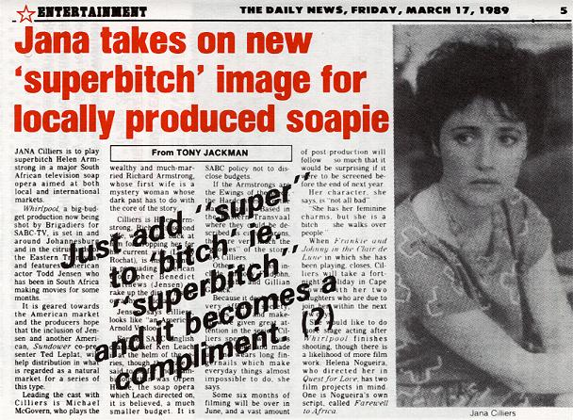
ONLY DERAMING SEX WITH QUEEN
Chamcha (another name of Rushdie in the TSV, see page 12) he found himself dreaming of the Queen, of MAKING TENDER LOVE to the MONARCH. She was the body Britain, the avatar of the state, and he had chosen her, JOINED WITH HER; she was his Beloved, the moon of his delight." [ Mark this quotation with green marker and memorise it. ] (Page 169 of TSV.) What is Rushdie telling his readers, if not that he fucked her Majesty. "Joined with her," above compare with his expression "STILL CONJOINED," on page 12.
I expect some British blockhead of the literary world to cry "Oh! Rushdie only fucked our Queen in his dream." It is all fiction. After all, we can´t hold a man accountable for his dreams. That is true, but "O pervert!" Rushdie was not dreaming when he penned those words!
ALL "WHITE" WOMEN!
Lest the commoner say that "Rusdie only lampoons the high and mighty like the Prime Minister of Britian - Maggie - and the Monarch of Britain - The Queen!" Let me remind them that he has not forgotten you, the plebeian - the ordinary Whites in the country. Nay, he honours all whites, wheresoever they abide.
This choicest piece of racism should also be highlighted with a glowing green pen and memorised:
"WHITE WOMEN - NEVER MIND FAT, JEWISH, NON-DEFERENTIAL12 WHITE WOMEN - WERE FOR FUCKING AND THROWING OVER. "(PAGE 261 TVS)
In Rushdie´s perverted mind, the fate of every "white women" was for fucking and throwing over. The only qualification required by Rushdie is that they be "WHITE". It does not matter their shape or size. Whether with a hooled Jewish nose or an Anglo-Saxon angular nose. Whether you can recognise their nationality or not. Whether they be English, or Irish; Scottish or Weish; German or French; American or Canadian - provided they are white! "THEY ARE ONLY GOOD FOR DISCARDING AFTER FUCKING" SAYS RUSHDIE!
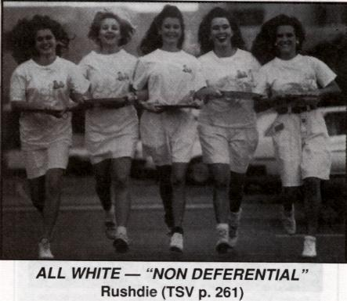
ALL WHITE - "NON DEFERENTIAL" Rushdie (TVS p. 261)
PUBLIC READING OF TVS
The Satanic Verses were being read in Britain and America. One Susan Sontag of the Literary Guild among others read this with religious regularity in New York to her doting audiences, both, black and white, young and old. Some Afro-American [Rushdie calls them "Niggers!" see page 461 TVS "Nigger eat white man's shit." And on page 446 "Niggerjimmy" and "mushroom". ]youths imbibed the message. "WHITE WOMEN ARE FOR FUCKING AND THROWING OVER!" For after all, what is reading if not brain-washing. We are what we eat and we are what we read! Dr Vernon Jones, an American psychologist of great repute, carried out experiments on groups of school children to whom certain stories were being read, and at the end of his experiments he concluded "that these stories made certain slight but permanent changes in character, even in the narrow classroom situation."
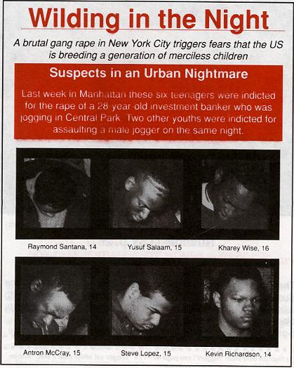
SATANIC INSPIRATION
Susan Sontag, a white woman, relished her reading of "The Satanic Verses". So did her admirers. One young listener was inspired! He was waiting for an opportunity to put Rushdie´s idea into action. It didn´t take long. Soon afterwards with five others - the gang of six - one Muslim and five Christians were prowling at night in Central Park, looking for adventure.
They saw a "WHITE WOMAN" jogging. She triggered their imagination! They went a "W-I-L-D-I-N-G" [ WILDING: A new word meaning, went berserk sexually; like a pack of wolves scenting blood! ]as the "Times" magazine, of 8th May, 1989, reports. They bashed the poor woman into unconsciousness, and fell on their prey like a pack of wolves.
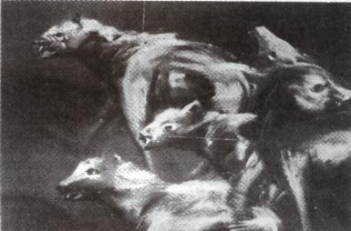
WOVES DON'T GO A "WILDING"!
They gang-raped her one by one in turn which no wild beast ever does. The blood and the sweat and the gore titillated their libido!
That poor jogger was an innocent victim. It should have been Susan Sontag, or Marriane Wiggins (Rushdie´s second wife) who says that if she was not Rushdie's wife then she too would have read "The Satanic Verses" to her clientele, in public from city to city.
TVS SHOULD BE READ TO ALL BLACKS!
If I was a sadistic racist, I would have liked to have "The best of Rusdie" read in Harlem, New York; and in every ghetto in America and in Notting Hill in the U.K. and among all the blacks of the world, in Africa and in Asia and in Eskimo-land. Let the non-Whites of the world know that according to Rushdie's new Bible - "WHITE WOMEN - NEVER MIND FAT, JEWISH, or NON-DEFERENTIAL WHITE WOMEN - WERE FOR FUCKING AND THROWING OVER"!
You, Peter Mayar! Director of viking/Penguin, you son of a bitch, you gave Rushdie 800,000.00 Dollars as advance money for this filth.
All those whites - Poets and Playwrights, Essayists and Editors, Novelists and Newsmen who are in support of Rushdie's smut, let them read the above quotation from the shit of Rushdie to their mothers, to their wives and daughters. Make their mouths water, that Rushdie wants them to be fucked by black people and thrown away. Rushdie has already set the example, he has FUCKED AND THROWN AWAY (one British girl, his first wife) and perhaps before you get this into your hands, he would have done the same to another (American girl - Marriane Wiggins) also FUCKED AND THROWN AWAY [STOP PRESS:Prophecy fulfilled end August. Wiggins wiggles out of marriage!]
I am asking all those sons of bitches who rushed to Rushdie´s support without really reading his TVS, the real reason for their unqualified support. Did they not come across these "tasty eats"?
"MOTHER-FUCKING AMERICANS" TVS p 80
"MOTHER-FUCKING SPARKS" TVS p 85
"MOTHER-FUCKING DREAMS" TVS p 122
"BHANCHUD [Bhanchud:Means "sister-fucking" in the gutter lingo of Bombay. Rushdie wisely questions on page 441 TSV "How are you supposed to understand a man who writes a made-up lingo of his own?"] NIGHTMARE" TVS p 109.
COMPARED WITH WHORES
There is no end to Rushdie´s shit. He has 547 pages full of it. Though he has some brilliant things to say at times. He equates himself, and all the writers, authors, novelists etc. With hookers and harlots, prostitutes and pimps. He makes one of his characters to utter:
"WRITERS AND WHORES. I SEE NO DIFFERENCE HERE." TVS p 392
TRIBUTE TO RAJIV
Before I end this most agonising little essay I had ever written, I must thank Rajiv Gandhi for being about the first (?) country in the world to ban "The Satanic Verses." Stop attributing motives to people! My own country, the Republic of South Africa, was in the forefront on banning the book, as well as debarring Rushdie from entering the country. This was in early October 1988! Long before many a Muslim nation!
I congratulate the Prime Minister of India for his sagacious move. The devilish book would not only have wounded his Muslim subjects in India but it would have also seared his Hindu coreligionists as well. The devil Rushdie has spared no one.
RAMA REVILED
Nobody has yet drawn the attention of Rushdie's Hindu admirers as to what he has to say about the gods and goddesses of their faith. "HERE WAS A LECHEROUS, DRUKEN RAMA AND A FLIGHTY [ Does not mean "full of flight", as one running away from illicit sexual advances, but as one who is sexually frivolous and irresponsible. Easily excited, easily sexually. ] SITA: WHILE RAVANA, THE DEMON KING, WAS DEPICTED AS AN UPRIGHT AND HONEST MAN "GIBREEL (that's Rushdie himself again in this TVS) IN PLAYING RAVANA," GEORGE EXPLAINED IN FASCINATED HORROR. "LOOKS LIKE HE'S TRYING DELIBERATELY TO SET UP A FINAL CONFRONTATION WITH RELIGIOUS SECTARIANS, KNOWING HE CAN'T WIN, THAT HE'LL BE BROKEN TO BITS." TVS P539.
Rama the 7th incarnation of god, according to the Hindu religion, venerated and worshipped by hundreds of millions of Hindus in India, is character - assassinated as a lecher, one given to excessive sexual cravings and debauchery, and the demon-king is portrayed here as a righteous man. And Sita is painted as a flirt. This is typical Rushdie. He turns gods into devils and devils into saints! And the Swiney confesses that the likes of him "WILL BE BROKEN TO BITS!" - "GUY SEEMS HELL - BENT ON A SUICIDE COURSE." TVS page 538. He has uttered here words of wisdom, but alas, he has learnt nothing from them himself.
BEFITTING END
Mired in misery, may all his filthy lucre choke in his throat, and may he die a coward's death, a hundred times a day, an eventually when death catches up with him, may he simmer in hell for all eternity.

