THE MUSLIM AT PRAYER
by
Shaikh Ahmed Deedat
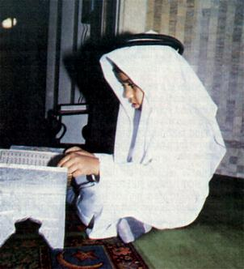
THE OPENING CHAPTER OF THE HOLY QUR'AN
In the name of Allah (God), The Most Compassionate, the Most Merciful. All praise belongs to Allah, the Lord (Who is the Creator, Sustainer and Guide) of all the worlds.
The Most Compassionate, the Most Merciful; Sovereign of the Day of Judgement.
Thee (alone) do we worship, And from thee (alone) we seek help.
Show us the straight Path, The Path of those (who fear Allah) and on whom Thou hast bestowed Thy blessings.
Not of those (committing wrongs deliberately) On whom Thou art angry, nor of those who (Having wrong opinions) go astray. Ameen
YOUR VISIT TO THE MOSQUE
We present to you this Brochure which is a Comparative Study of Muslims Prayer. It is intended to show in it, among other things, the relationship of the various aspects of Islamic prayer with the teachings of the People of the Book (i.e. the Jews and the Christians). Today, amongst some of our non-Muslims Brethren there is a strong misconception of Islam which they believe to be a mystical cult abounding in dogmas, superstitions and ritual dances.
The fact is that Islam is a simple, reasonable and practical religion and free from priestcraft and the above charges. It is a way of life for the social, moral and spiritual development of humanity. It does not demand of a man to surrender his reasoning faculties nor does it demand a blind faith in obscure and inexplicable mysteries. It teaches the purest form of Monotheism and regards Polytheisms as an unpardonable sin.
Although Islam is regarded as the youngest of all revealed religions, it is NOT A NEW RELIGION, but a continuation of the first religion of God to Man, purged and purified, time after time, from all human adulterations and restored to its original purity.
Thus all prophets from Adam to Muhummed (PEACE BE UPON THEM) came to preach the same religion; which continued to grow and grow until it reached perfection at the hands of the Holy Prophet "Muhummed".
Islam is the only religion in the world that commands its followers to respect and revere the founders of all revealed religions, such as Abraham, Moses, Noah, Jesus,etc.
Muhummed´s advent has been prophesied in religious scriptures, includung the Bible.* The New Testament says, in the words of Jesus: "And I will Pray the Father, and He shall give you another Comforter,** that he may abide with you for ever" (John 14:16); "But when the Comforter is come, whom i will send unto you, from the Father, even the Spirit of Truth, which proceedeth from the Father, he shall testify of me" (John 15:26); "Nevertheless I tell you the truth; it is expedient for you that I go away; for the if I go not away , the Comforter will not come unto you; but if I depart, I will send him unto you" (John 16:7) ; "I have yet many things to say unto you, but ye cannot bear them now. Howbeit when he, the Spirit of Truth, is come, he will guide you into all truth : for he shall not speak of himself: but whatsoever he shall hear, that he shall speak: and he will shew you things to come. He shall glorify me: for he shall receive of mine, and shall show it unto you" (John 16:12-14).
THE QURAN SPEAKS! Vol. II-No. 47 GOD BEGETS NOT
It is not befitting to the (Majesty of) God that He should beget a son. Glory be to Him! When he determines a matter, he only says to it, "Be" and it is, (HOLY QURAN 19:35).
Begetting a son is a physical act and is against God´s nature. "Son of God" should NOT be taken in literal sence because God addresses His chosen servants as his "sons" - Adam (Luke 3:38) So Solomon (1 Chronicles 28:6), Jesus (Luke 3:22) Israel (Exodus 4:22) and Ephraim (Jeremiah 31:9) were "GOD´S FIRST BORNS". The new Testament also interprets "son of God" to be allegorical, vide Romans 8:14: "For as many as are led by the Spirit of God, they are the sons of God." "... In this the children of God are manifest, and the children of the Devil.." (1 John 3:9-10).
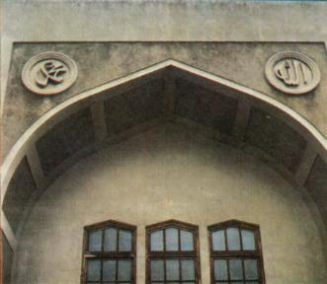
"There is no other object of worship but God; Muhummed is the Messenger of God."
"Say: He is Allah (God), the One and Only; Allah the eternally Besought of all; He begetteth not, nor is He begotten; And there is none comparable unto Him." (HOLY QURAN 112.1-4).
"..To whom then will ye liken God? Or what likeness will ye compare unto Him?"- (ISAIAH 40:18).
"Then saith Jesus unto him, Get thee hence Satan, for it is written, thou shalt worship the Lord thy God, and Him only shalt thou serve. "-(MATTHEW 4:10).
Five times a day, every day, a muezzin climbs to the minaret and calls the faithful to prayer, his voice ringing clear over the rooftops and across the streets... "O you who belive! When the call is made for prayer...hasten to the remembrance of Allah."-(HOLY QURAN 62:9).
"And the Lord spake unto Moses, saying, make thee two trumpets of silver...that thou mayest use them for the calling of the assembly...And when they shall blow whit them, all the assembly shall assemble themselves to thee at the door of the tabernacle of the congregation."-(NUMBERS 10:1-3).
PRAYER
(An International anthem of some 1000 million Muslims of the world.)
Allah is Greatest.
Allah is Greatest
I bear witness that there is no other object of worship but Allah.
I bear witness that there is no other object of worship but Allah.
I bear witness that Muhummed is the Messenger of Allah.
I bear witness that Muhummed is the Messenger of Allah.
Come to prayer.
Come to prayer.
Come to Success.
Come to Success.
Allah is Greatest.
Allah is Greatest.
There is no other object of worship but Allah.

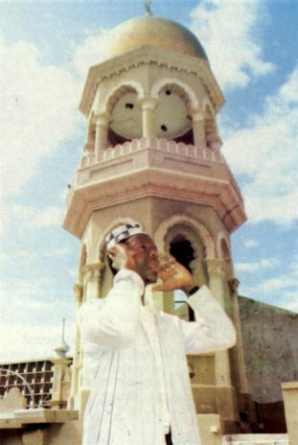
THE MUEZZIN CALLING THE FAITHFUL TO PRAYER
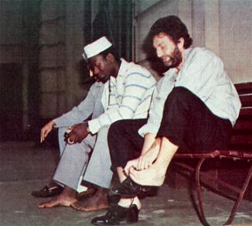
...the faithful come to the mosque and take off their shoes so that they may enter the house of worship in bare feet...
"When he came to the Fire, a voice was uttered: O Moses! I am thy Lord, therefore put off thy shoes, for thou art in the sacred valley of Tuwa."-(HOLY QURAN 20:11-12).
(And God said to Moses), "Draw not nigh hither: put off thy shoes from thy feet, for the place whereon thou standest is holy ground."-(EXODUS 3:5, also ACTS 7:33).
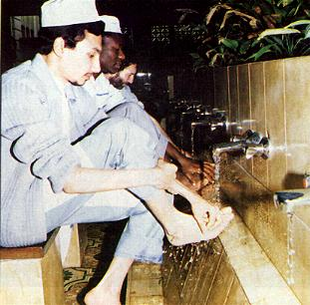
...but before entering the mosque, they make ablution, washing their faces, hands and feet...
"O you who belive! When you rise up to prayer, wash your faces and your hands as far as the elbows, and wipe your heads, and wash your feet to the ankles."-(HOLY QURAN 5:7)
"And Moses and Aaron and his sons washed their hands and their feet thereat; when they went into tent of the conregation they washed as the Lord commanded Moses."-(EXODUS 40:31-32).
"Then Paul took the men, and the next day purifying himself with them entered into the temple..."-(ACTS 21:26).
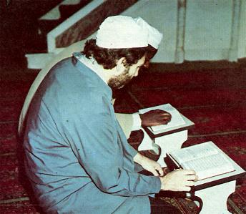
...and in the mosque, the faithful face that Great Mosque in Mecca, whether in prayer, or reciting, or seeking the blessings of God in Unisom with the faithful from all over the world...
"So turn thy face toward the Sacred Mosque, and (O Muslims), wheresoever ye may be, turn your faces toward it."- (HOLY QURAN 2:144).
"Now when Daniel...went into his house; and his window being open in his chamber towards Jerusalem, he kneeled upon his knees three times a day, and prayed, and thanks before his God, as he did aforetime."-(DANIEL 6:10).
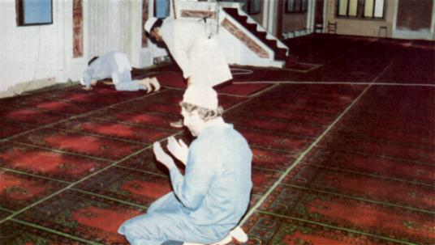
...the house is a place of peace and serenity, without images or idols of worship, and simple, with a carpet on which to stand or sit, and meditate.
"God forgiveth not (the sin of) joining other gods with Him;...one who joins other gods with God, hath strayed far, far away (from the Right)."-(HOLY QURAN 4:116).
"I am the Lord thy God...Thou shalt have no other gods before Me. Thou shalt not make unto thee any graven image, or any likness of anything that is in heaven above, or that is in the earth beneath, or that is in the water under the earth; Thou shalt not bow down thyself to them nor serve them."-(THE FIRST COMMANDMENT, EXODUS 20:2-5).
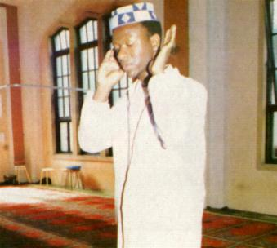
...and when the time of prayer is come, the faithful stand and bow before God, and make obeisance to Him, by touching the ground before them with their foreheads...
They do blaspheme who say: "God is Christ, the son of Mary." But said Christ:" O Children of Israel! Worship God, my Lord and your Lord."-(HOLY QURAN 5:75).
They do blaspheme who say: God is one of three in a Trinity: for there is no god except One God.-(HOLY QURAN 5:76).
And, behold, one came and said unto him (Jesus), "Good Master, what good thing shall I do, that I may have eternal life?" And he said unto him, Why callest thou me good? There is none good but One, that is God: but if thou wilt enter into life, keep the Commandments.-(MATTHEW 19:16-17).
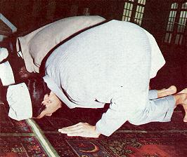
"O you who believe! Bow down and prostrate yourselves and serve your Lord, and do good that you may prosper."-(HOLY QURAN 22:77).
"And he (Jesus) went a little further, and fell on his face, and prayed..."-(MATTHEW 26:39).
"And Joshua fell on his face to the earth, and did worship..."-(JOSHUA 5:14).
"And he (Elijah) cast himself down upon the earth, and put his face between his knees."-(1 KINGS 18:42).
"And they (Moses and Aaron) fell upon their faces..."-(NUMBERS 20:6).
"And Abraham fell on his face..."-(GENESIS 17:3).
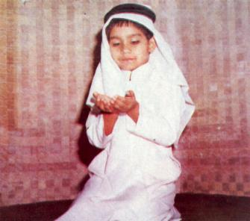
...and invariably, the faithful spreads out his hands to God, asking forgiveness, seeking His blessings, beseeching His protection for mankind...
"Our Lord! Give us good in this world and good in the Hereafter, and defend us from the torment of the Fire."-(HOLY QURAN 2:201)
"...when Solomon had made an end of praying all this prayer and supplication unto the Lord, he arose from before the altar of the Lord, from kneeling on his knees with his hands spread up to heaven."-(1 KINGS 8:54).
And Jesus lifted up his eyes, and said, Father, I thank thee that thou hast heard me. And I knew that Thou hearest me always: but because of the people which stand by I said it, that they may believe that Thou hast sent me.-(JOHN 11:41-42).
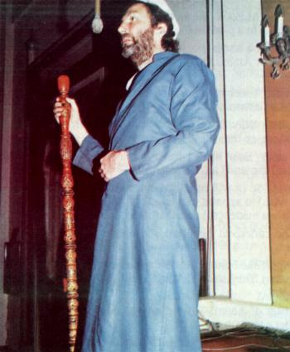
...and on Fridays, before the prayer immediately after noon, the imam climbs up the pulpit to preach a sermon that the faithful may listen and heed the words of God, and so shall it be, forever.
"When the call is sounded for prayer on Fridays, hasten to the remembrance of God...but when the prayer is ended, disperse abroad in the land and seek of God´s grace and remember God, that you may be successful."-(HOLY QURAN 62:9-10).

BIRTH OF JESUS (A QURANIC CONCEPTION)
Relate in the Book (the story of) Mary, when she withdrew from her family to a place in the East.
She placed a screen (to screen herself) from them; then We sent to her Our Angel, and he appeared before her as a man in all respects.
She said: "I seek refuge from thee to (God) Most Gracious: (come not near) if thou dost fear God."
He said: "Nay, I am only a messenger from thy Lord, (to announce) to thee the gift of a holy son."
She said: "How shall I have a son, seeing that no man has touched me, and I am not unchaste?"
He said: "So (it will be): Thy Lord saith, "That is easy for Me: and (We wish) to appoint him as a Sign unto men and a Mercy from Us: It is a matter (so) decreed."
So she conceived him, and she retired with him to a remote place...
At length she brought (the babe) to her people, carrying him (in her arms). They said: "O Mary! Truly an amazing thing has thou brought!
"O sister of Aaron! Thy father was not a man of evil, nor thy mother a woman unchaste!"
But she pointed to the babe. They said: "How can we talk to one who is a child in the cradle?"
He (the babe) said: "I am indeed a servant of God; He hath given me Revelation and made me a prophet: And he hath made me blessed wheresoever I be, and hath enjoined on me Prayer and Charity as long as I live; (He) hath made me kind to my mother, and not overbearing or misrable; so Peace is on me the day I was born, the day that I die, and the day that I shall be raised up to life (again).
Such (was) Jesus the son of Mary: (it is) a statement of truth, about which they (vainly) dispute.-(HOLY QURAN 19:16-34).
THE QURAN SPEAKS VOL. 11-No.36 JESUS IS NOT GOD
And behold. God will say: "O Jesus son of Mary! Did´st thou say unto men, Worship me and my mother as gods in derogation of God?" He will say: "Glory to Thee! Never could I say what I had no right (to say). Had I said such a thing, Thou would´st indeed have known it. Thou knowest what is in my heart, though I know not what is in Thine. For thou knowest in full all that is hidden. Never said I to them aught except what Thou did´st command me to say, to wit, worship God, my Lord and your Lord." (HOLY QURAN 5:119-120).
Compare with Bible: (1) John 5:30; (2) John 12:49; (3) John 14:28; (4) Isaiah 42:8; (5) Acts 2:22.
THE QURAN SPEAKS VOL. 111-No.4 MUHUMMED IS NOT GOD
Say thou (O Muhummed to the people): "I am but a man like you: it is revealed to me by inspiration, that your God is One God: so stand true to Him, and ask for His forgiveness". And woe to those who join gods with God. (HOLY QURAN 41:6)
Some people maintain that Muslims worship Muhummed instead of God, and call them "Muhummedans". The above verse gives the lie to such an allegation as Muhummed never claimed himself to be a god. He was a prophet like any other messenger of God. The word "Muhummedanism" as applied to the Islamic religion is a misnomer. Islam means submission to the Will of God and its followers are called Muslims.
How then can man be justified with God? Or how can he be clean that is born of a woman?-(JOB 25:4).
THE FOLLOWING EXTRACTS FROM THE BIBLE BEAR TESTIMONY TO THE QURANIC TRUTH THAT JESUS IS NOT GOD
Ye men of Israel, hear these words; Jesus of Nazareth, a man approved of God among you by miracles and wonders ans signs, which God did by him in the midst of you, as ye yourselves also know.-(ACTS 2:22).
"And I fell at his feet to worship him. And he said unto me See thou do it not: I am thy fellow servant, and of thy brethren that have the testimony of Jesus: worship God...-(REVELATION 19:10)
For I have not spoken of myself; but the Father which sent me, He gave me a commandment, what I should say, and what I should speak.-(JOHN 12:49).
I can of mine own self do nothing: as I hear, I judge: and my judgment is just; because I seek not mine own will, but the will of the Father which hath sent me.If I bear witness of myself, my witness is not true.-(JOHN 5:30-31).
...for my Father is greater than I.-(JOHN 14:28).
And this is life eternal, that they might know Thee the only true God, and Jesus Christ, whom Thou hast sent.-(JOHN 17:3)
Verily, verily, I say unto you, The servant is not greater than his Lord; neither he that is sent greater than He that sent him.-(JOHN 13:16)
John 20:17 Jesus saith unto her (Mary Magdalene)... I ascend unto my Father, and your Father; and to my God, and your God.-(JOHN 20:17)
But of that day and that hour knoweth no man, no, not the angels which are in heaven, neither the Son, but the Father.-(MARK 13:32)
But now ye seek to kill me, a man that hath told you the truth, which I have heard of God.-(JOHN 8:40).
"It was the first religion that preached and practised democracy; for, in the mosque when the call from the Minaret is sounded and the worshippers are gathered together, the democracy of Islam is embodied five times a day when the peasant and the king kneel side by side and proclaim, "God alone is great." I have been struck over and over again by this indivisible unity of Islam that makes a man distinctively a brother."
THE LATE SIROJINI NAIDU - A GREAT HINDU POETESS, RIGHTLY DESCRIBED AS THE "NIGHTINGALE OF INDIA."
*Muhummed is mentioned by name in song of Solomon 5:16. The Hebrew word used is "Mahummudim".
**The word "comforter" is the English translation of the Greek word "Peri clytos" which is almost a literal translation of the Aramaic or Hebrew word "Mauhamana" used by Jesus himself, and which identifies with the name of Prophet Muhummed. (Refer Note 5438. - Yusuf Ali Translation of the Holy Quran).

